Steps to configure and run the application in IIS

1. Create DataBase **EmployeeDB** in SQL server database and use below script to create table named “**UserContacts**”.

CREATE TABLE [dbo].[UserContacts](

[ID] [int] IDENTITY(1,1) NOT NULL,

[[First Name] [nvarchar](50) NOT NULL,

[:ast Name] [nvarchar](50) NOT NULL,

[Email] [nvarchar](120) NOT NULL,

[Phone Number] [int] NOT NULL,

[Status] [bit] NULL,

CONSTRAINT [PK_UserContacts] PRIMARY KEY CLUSTERED

(

[ID] ASC

)WITH (PAD_INDEX = OFF, STATISTICS_NORECOMPUTE = OFF, IGNORE_DUP_KEY = OFF, ALLOW_ROW_LOCKS = ON, ALLOW_PAGE_LOCKS = ON) ON [PRIMARY]

) ON [PRIMARY]

1. Copy folder **EvolentCodingProject** in **C:\inetpub\wwwroot**.
2. Go to IIS 🡪 Sites 🡪 Default Website and right click folder “EvolentCodingProject” and click Convert to Application.

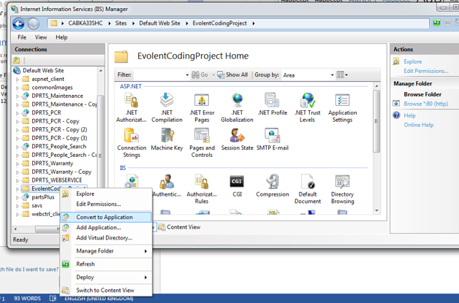

1. In Add Application window click Select. Select application pool as below (Pipeline Mode should be Integrated). Click OK and OK.

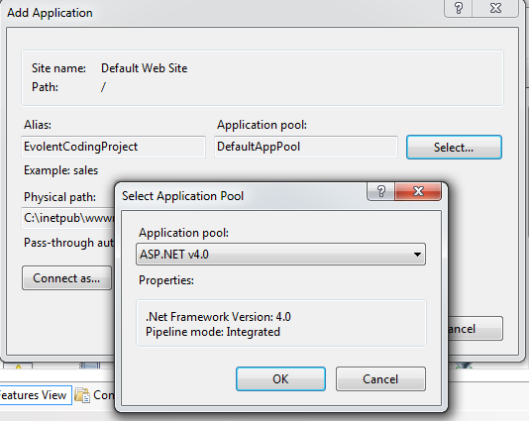

1. Currently application is configured to allow all users, so authentication is anonymous. Application is connected to local database, so please ensure ApplicationPoolIdentity for your application pool set to Local System.

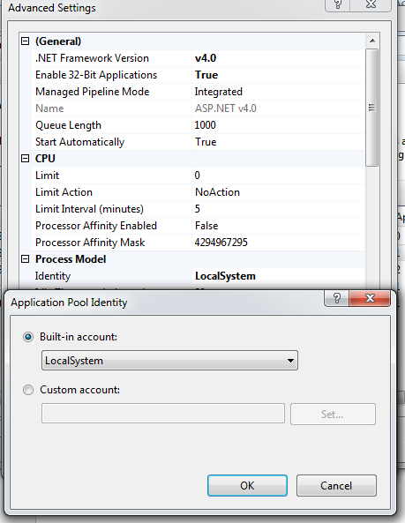

1. If application is hosted on local IIS, please use URL <http://localhost/EvolentCodingProject> to access the application.
2. If you are using remote SQL Database server then you need to update your ConnectionString accordingly.